**Recursive Descent Parsing**

#include<stdio.h>  
#include<conio.h>  
int c=0;  
char p[20];  
void s();  
void l();  
void lprime();  
void l()  
{  
s();  
lprime();  
}  
void lprime()  
{  
if(p[c]==',')  
{  
c++;  
s();  
lprime();  
}  
}  
void s()  
{  
if(p[c]=='a')  
c++;  
else if(p[c]=='(')  
{  
c++;  
l();  
if(p[c]==')')  
c++;  
else  
c--;  
}  
else  
printf("\nInvalid Expression");  
}  
void main()  
{  
clrscr();  
printf("\nImplementation of RECURSIVE DESCENT PARSER\n");  
printf("\nEnter the Expression:\n");  
scanf("%s",p);  
s();  
if(p[c]=='$')  
printf("\nThe String is accepted");  
else  
printf("\nThe string is rejected");  
getch();  
}

OUTPUT:

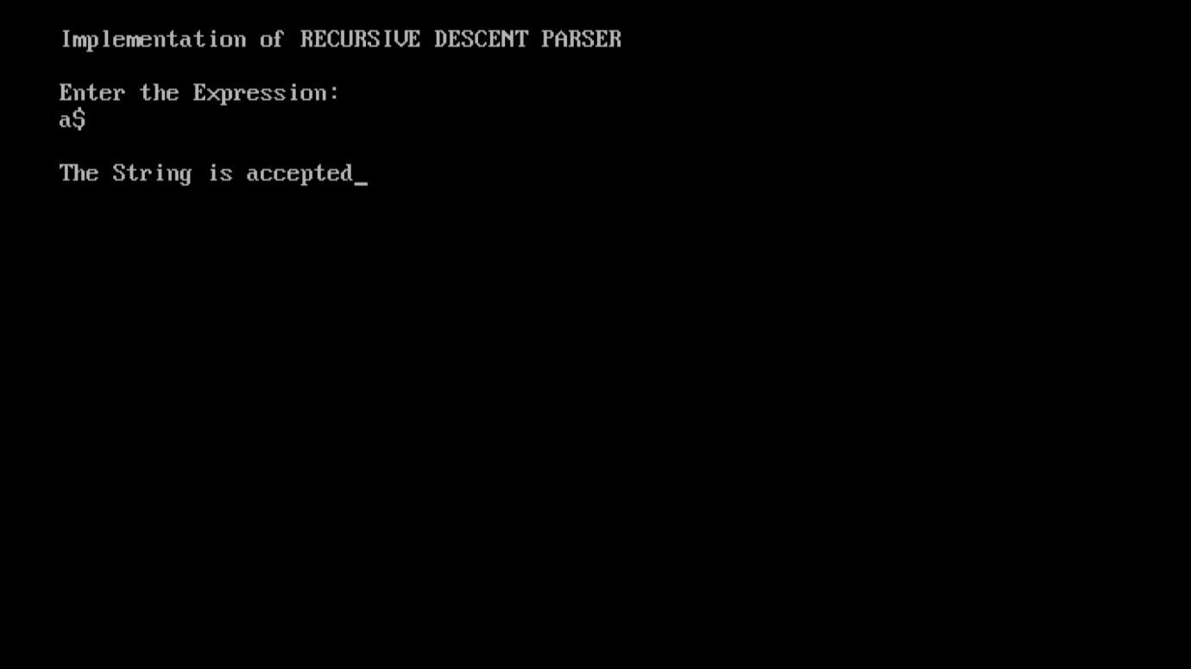

**Recursive Descent Parsing Output Result**  
Implementation of RECURSIVE DESCENT PARSER  
Enter the Expression:  
a  
The string is rejected  
Implementation of RECURSIVE DESCENT PARSER  
Enter the Expression:  
a$  
The String is accepted  
Recursive Descent Parsing OUTPUT  
Implementation of RECURSIVE DESCENT PARSER  
Enter the Expression:  
(a)$  
The String is accepted  
  
Implementation of RECURSIVE DESCENT PARSER  
Enter the Expression:  
b*c  
Invalid Expression  
The string is rejected